User Guide and Assumptions
MSME Payables Compliance Tracker — supporting document

1. Getting started
- Install Python 3.10 or newer from python.org (on Windows tick “Add Python to PATH”).
- Unzip the project, open the `msme_tracker` folder (inside `4_Executable_Files`) and double-click Start_MSME_Tracker.bat. The first run installs the required packages and needs internet; afterwards it starts immediately.
- The app opens in your browser. Close the black window to stop it. On other systems run `pip install -r requirements.txt` and `streamlit run app.py`.

2. Step-by-step use

Step 1 – Company and vendor master
Add a company in the sidebar (or pick an existing one). In tab 1 · Vendor Master, upload the vendor master (merge into the existing one, or replace it) or edit it directly in the table. It is saved for that company.
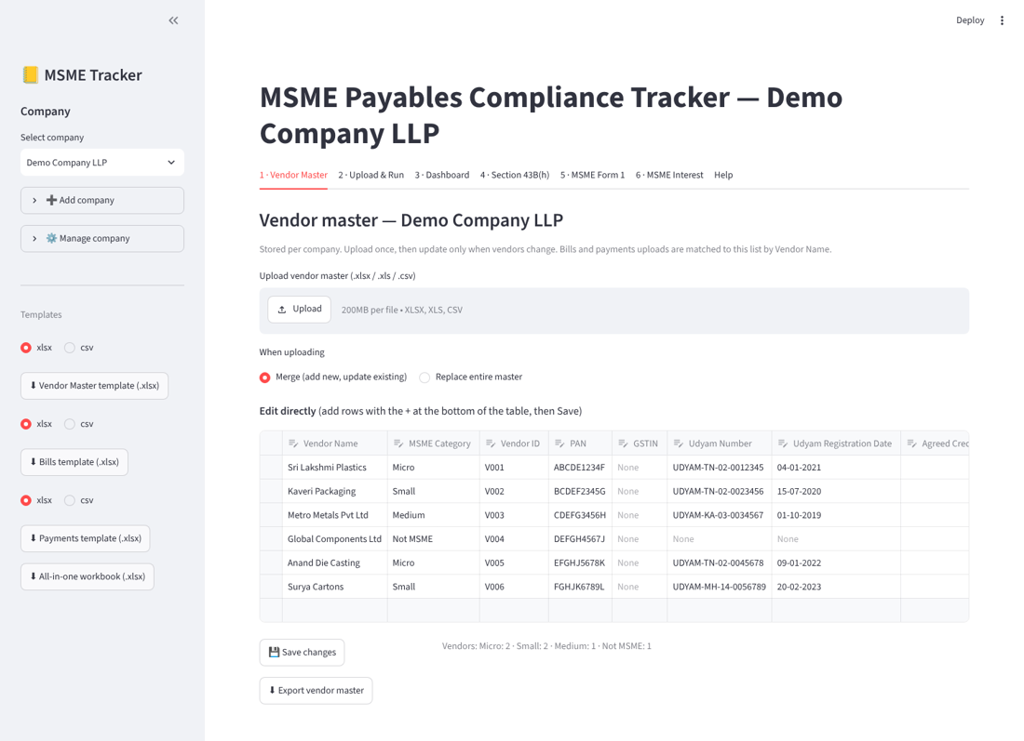
Vendor Master tab.

Step 2 – Load transactions
In tab 2 · Upload & Run choose the source: Standard templates (upload Bills and, optionally, Payments), or Vendor statements / software exports (see section 4). Set the as-of date and the financial year (for example 2025 means 1 April 2025 to 31 March 2026), then click Run tracker.
After a run, use Save run to keep it. Saved runs appear under Saved runs at the top of the tab and can be reopened later; by default the vendor master saved with the run is used, so a filed return reproduces exactly.
Opening balances (optional). If your bills file covers only the current period but earlier bills are still unpaid, open Opening balances in the same tab. Choose Bill-wise (each unpaid bill with its Bill No and Bill Date – recommended) or Party-wise (one total per vendor), set the Opening balance as at date (default: the day before the financial year starts), then upload the Opening Balances template or type rows in the table. The unpaid amounts are added as bills, so later payments reduce them. Party-wise totals have no bill dates, so they are dated from the opening date (or a date you enter) and will look younger than they really are. Do not repeat the same bills in the bills file, and keep payments made before the opening date out of the payments file.
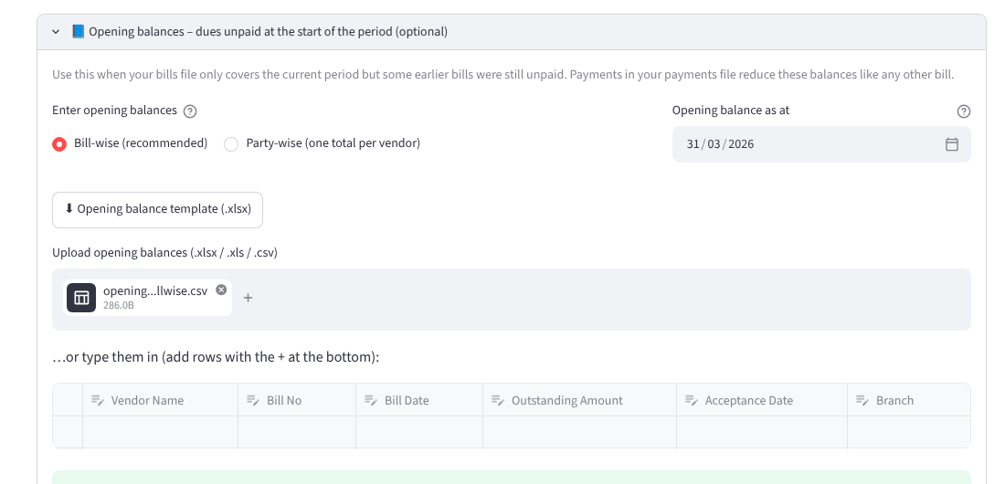
Opening balances section of the Upload & Run tab.
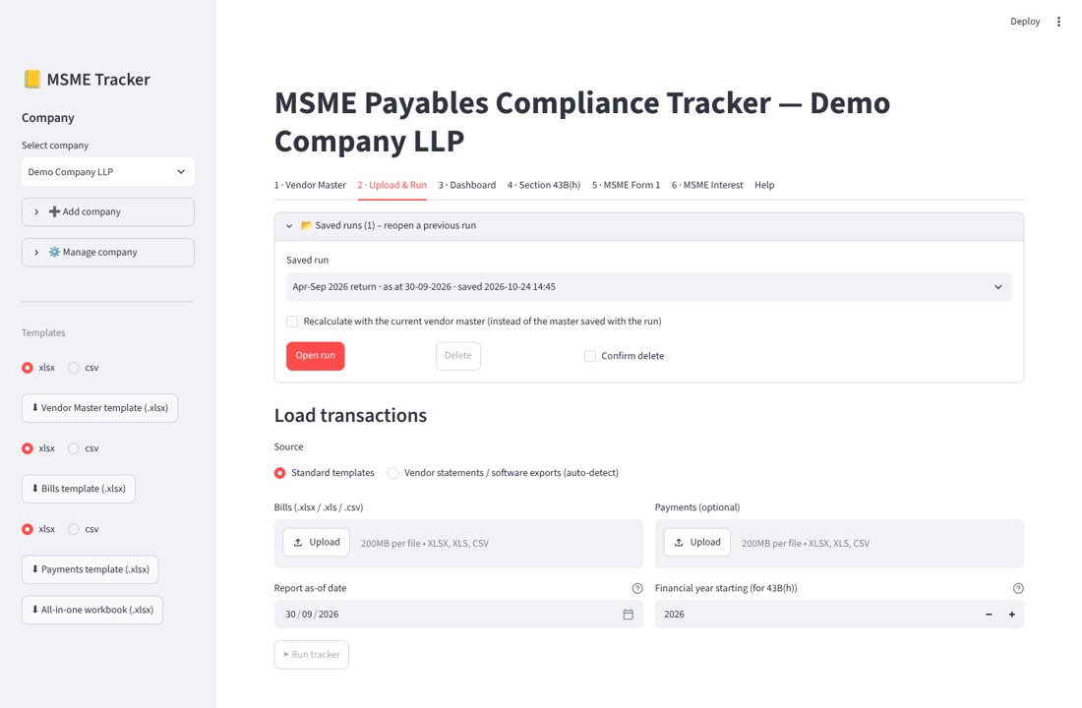
Upload & Run tab with the Saved runs panel open.

Step 3 – Review the results
- 3 · Dashboard – exposure, ageing, top vendors, branches, trend, pay-by list, all bills; download the ledger.
- 4 · Section 43B(h) – disallowance, not-yet-due bills and prior-year reversals; download the workbook.
- 5 · MSME Form 1 – the return in the (a)–(h) layout; type the reason for delay per supplier; download the workbook.
- 6 · MSME Interest – Section 16 interest by supplier and by bill; the Bank Rate table and multiplier can be edited.
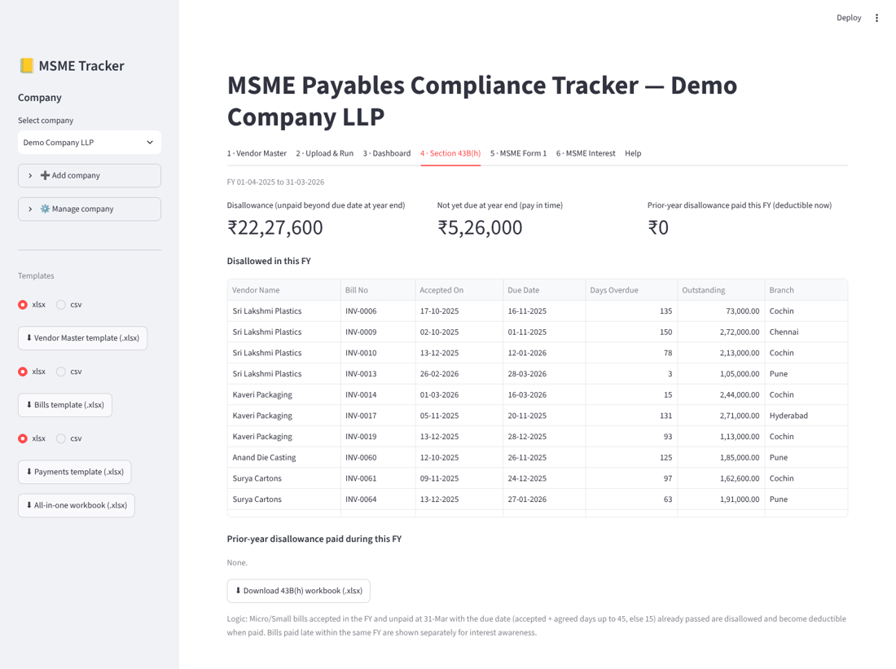
Section 43B(h) tab.

3. Input files
Download blank templates from the sidebar (or use the files in `Blank_Input_Templates`). Required columns are marked; optional columns can be left blank. Dates are read day-first (dd-mm-yyyy). Column headings are matched flexibly (for example “Invoice No” is read as “Bill No”), but required columns must exist.

Vendor Master
Column | Required | What to enter | Example
Vendor Name | Yes | Supplier name exactly as in your books. Used to link Bills and Payments. | Sri Lakshmi Plastics
MSME Category | Yes | Micro, Small, Medium or Not MSME (as per Udyam certificate). | Micro
Vendor ID | Optional | Your internal vendor code (informational). | V0001
PAN | Optional | Supplier PAN (printed on Form 1). | ABCDE1234F
GSTIN | Optional | Supplier GSTIN (informational). | 33ABCDE1234F1Z5
Udyam Number | Optional | Udyam registration number. | UDYAM-TN-02-0012345
Udyam Registration Date | Optional | Bills accepted before this date are not treated as covered. Leave blank if unknown. | 01-04-2021
Agreed Credit Days | Optional | Credit days in a WRITTEN agreement. Blank = no agreement (15 days applies). Values above 45 are capped to 45. | 30

Bills
Column | Required | What to enter | Example
Bill No | Yes | Supplier invoice / bill number. | INV-2026-0101
Vendor Name | Yes | Must match a Vendor Name in the Vendor Master. | Sri Lakshmi Plastics
Bill Date | Yes | Date of the bill. | 12-07-2026
Bill Amount | Yes | Amount payable to the vendor (as you want it tracked, e.g. incl. GST). Must be > 0. | 118000
Acceptance Date | Optional | Date of acceptance/deemed acceptance of goods or services. Blank = Bill Date is used. | 14-07-2026
Description | Optional | Free text (informational). | Moulded housings
Branch | Optional | Branch / cost centre for slicing the dashboard (informational). | Chennai

Payments
Column | Required | What to enter | Example
Vendor Name | Yes | Must match a Vendor Name in the Vendor Master. | Sri Lakshmi Plastics
Payment Date | Yes | Date of payment / settlement. | 20-08-2026
Amount Paid | Yes | Amount paid. Record credit notes / adjustments as payments too. | 50000
Bill No | Optional | Bill this payment settles. Blank = on-account; applied to the vendor's oldest open bills (FIFO by due date). | INV-2026-0101
Reference | Optional | Cheque / UTR / voucher no (informational). | UTR123456
Payment Mode | Optional | TReDS or Other (blank = Other). Drives Form 1 column (d)(i) vs (d)(ii). | TReDS

Opening Balances
Column | Required | What to enter | Example
Vendor Name | Yes | Must match a Vendor Name in the Vendor Master. | Sri Lakshmi Plastics
Outstanding Amount | Yes | Amount unpaid to this vendor at the opening date. Party-wise: one total per vendor. Bill-wise: the unpaid part of each bill. | 250000
Bill No | Optional | Bill-wise mode: required. Party-wise mode: leave blank. | INV-2026-0044
Bill Date | Optional | Bill-wise mode: required. Party-wise mode: optional - the date the dues are assumed to date from (blank = opening date). | 15-03-2026
Acceptance Date | Optional | Bill-wise only. Blank = Bill Date is used. | 17-03-2026
Description | Optional | Free text (informational). | Moulded housings
Branch | Optional | Branch / cost centre (informational). | Chennai

4. Importing vendor statements and software exports
Choose Vendor statements / software exports in tab 2 and upload one or more files (.xlsx, .xls, .csv or text-based .pdf). For each file the app:
- finds the header row and maps the columns (Date, Vendor, Reference, Description, Type, Debit, Credit, Amount, Balance, Payment Mode) – you can change any mapping;
- works out the Debit/Credit convention: in a vendor's own statement a Debit is an invoice and a Credit a receipt; in your own ledger of the vendor it is the reverse. It infers this from the wording and lets you override it;
- classifies each row as Bill, Payment, Skip (opening balance, totals) or Review, using the Debit/Credit side, words such as invoice, receipt, NEFT, TReDS or credit note, running-balance movement, or the sign of the amount;
- matches vendor names to your master (exact, then close matches) and links each payment to the invoice number named in its narration.
Check the preview, change any row's Kind if needed, then click Add to this run. Imported data can be combined with template files in the same run; duplicates are counted once.
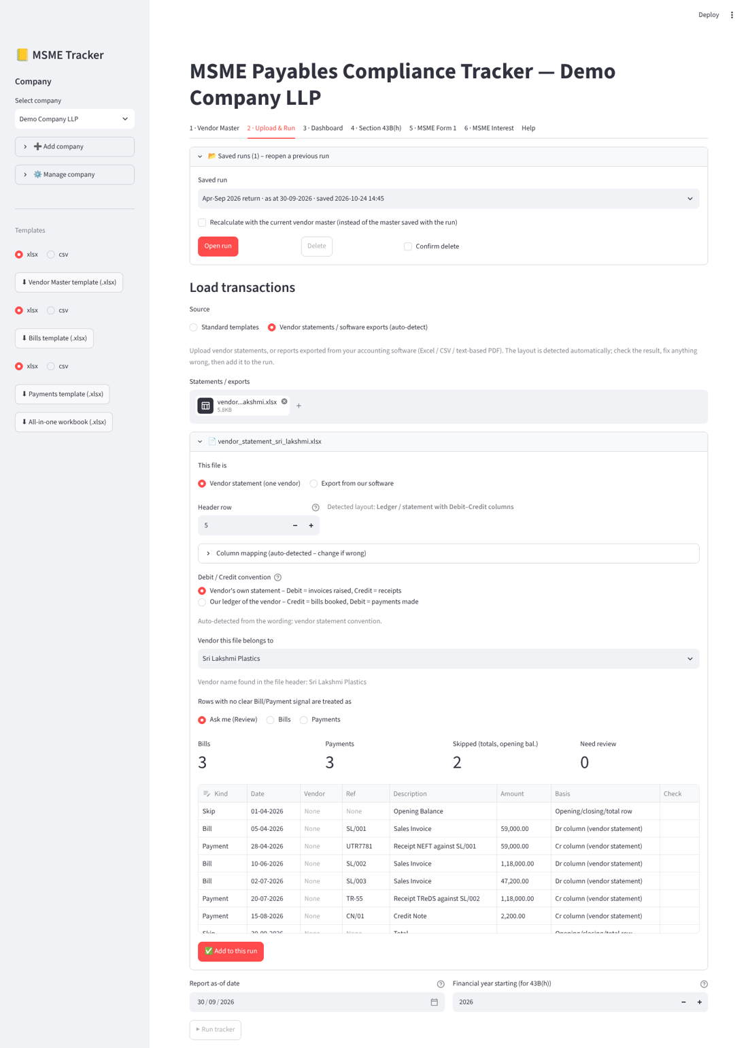
Import review screen for a vendor statement.

5. Rules and assumptions
Topic | Rule applied | Basis / assumption to confirm
Due date | Acceptance date (bill date if blank) + agreed days, capped at 45; no written agreement = 15 days. | MSMED Act s.15. Agreed days must come from a written agreement – record them in the vendor master.
Covered suppliers | Micro and Small only; bills accepted before the Udyam registration date are excluded. | Category per the supplier's Udyam certificate.
Opening balances | Unpaid amount at the opening date becomes a bill (bill-wise: real bill date; party-wise: opening date unless a date is given). Later payments reduce it. | Assumption: payments on or before the opening date are already in the balance; party-wise ageing is understated.
Payments | Named bill first; otherwise oldest due bill first. Credit notes and adjustments are entered as payments. | Assumption: a credit note settles the bill like a payment.
43B(h) | Covered bills accepted in the FY, unpaid at 31 March and past due are disallowed; deductible when paid in a later year. | Income Tax Act s.43B(h), FY 2023-24 onwards.
Form 1 (d)–(e) | Payments made from the period start to the as-of date, classed by days from acceptance (≤45 / >45); TReDS vs other by the Payment Mode column. | Assumption: paid columns cover the half-year period; a bill paid in parts can appear in more than one column.
Form 1 (f)–(g) | Dues outstanding at the as-of date, by days since acceptance (≤45 / >45); (g) includes unpaid bills from earlier periods. | Confirm the layout against the latest official format before filing.
Interest | 3 × Bank Rate in force each day; from the day after the due date; monthly rests; payments reduce principal only and interest stops when principal is cleared. | MSMED Act s.16 (not deductible: s.23). Assumption: payments are applied to principal, interest stays payable separately.
Statements | No acceptance date, so the bill date is used. | Add acceptance dates if you have them.

6. RBI Bank Rate table
Interest uses this table; it is editable in tab 6, which also has a Check latest Bank Rate on RBI website button and a link to the RBI home page (*Current Rates* box). The button only compares the published rate with your table; if it differs you enter the effective date (from the RBI press release) and confirm before it is added. Nothing is changed automatically, and the app works offline without it. The interest rate is three times the Bank Rate in force on each day. The latest entry (5.75% from 7 October 2026) matches the figure published on the RBI website at the time of writing; earlier entries should be verified against RBI notifications before relying on them.
Effective from | Bank Rate % (= MSF rate) | Interest rate % (3 ×)
04-05-2022 | 4.65 | 13.95
08-06-2022 | 5.15 | 15.45
05-08-2022 | 5.65 | 16.95
30-09-2022 | 6.15 | 18.45
07-12-2022 | 6.50 | 19.50
08-02-2023 | 6.75 | 20.25
07-02-2025 | 6.50 | 19.50
09-04-2025 | 6.25 | 18.75
06-06-2025 | 5.75 | 17.25
05-12-2025 | 5.50 | 16.50
07-10-2026 | 5.75 | 17.25

7. Outputs
File | Contents
Ledger and pay-by list | Every bill with due date, paid / outstanding amounts, status and ageing; bills due soon or overdue.
Section 43B(h) workbook | Disallowed bills, bills not yet due, prior-year reversals, bills paid late in the year.
MSME Form 1 workbook | Form 1 in the (a)–(h) layout with totals, plus a bill-level annexure of dues outstanding more than 45 days.
Interest workbook | Interest by supplier and by bill, and the Bank Rate table used.
All Excel outputs have bold headers, Indian digit grouping (for example 12,34,567.00) and live Total rows that respond to filters.

8. Data storage and privacy
- The app runs on your own computer; uploaded files are processed locally and nothing is sent to any server.
- Company profiles, vendor masters, saved runs and the Bank Rate table are stored in a `data` folder next to the app as plain files. Back up that folder to keep your work; set the `MSME_DATA_DIR` environment variable to store it elsewhere.
- Uploaded transactions are not kept unless you save the run.

9. Tests
The project includes 61 automated tests (run with `python -m pytest -q`). The full result is in `3_Example_Files/Test_Cases/Automated_Test_Results.txt`.
Test file | Area | Tests
test_engine.py | Core logic: due dates, status, allocation, Form 1, 43B(h), opening balances, file reading | 21
test_format.py | Indian number format, Excel styling and totals (incl. LibreOffice recalculation) | 17
test_importer.py | Statement / export import: layouts, classification, PDFs, vendor matching | 10
test_interest.py | Section 16 interest calculation | 10
test_store.py | Company storage and saved runs | 3
 | Total | 61

10. Troubleshooting and limitations
Problem | What to do
“Missing required column(s)” | Download the template and check the column headings, or use the statement/export import.
Vendors shown as “Unclassified” | The vendor is not in the vendor master (or the name differs). Add it in tab 1 and run again.
Payments flagged as unmatched | The payment names a Bill No that is not in the bills file. Correct the bill number or leave it blank to apply the payment oldest-first.
PDF cannot be read | It is probably scanned. Export from your software as Excel/CSV, or run OCR first.
Rows need review after import | Change their Kind in the preview, or switch the Debit/Credit convention if many rows are flagged.
This tool supports decision-making and is not legal or tax advice; confirm treatment with a qualified advisor.

